### Add a new Webpage after: Architecture of Computer System

Link: <https://www.studytonight.com/computer-architecture/architecture-of-computer-system>

Name of Webpage to be added:

**Logic Gates**

**Binary** information is represented in digital computers by physical quantities called ***signals***. Electrical signals such as voltages exist throughout the computer in either one of two recognizable states. The two states represent a binary variable that can be equal to 1 or 0. For example, a particular digital computer may employ a signal of 3 volts to represent binary 1 and 0.5 volt to represent binary 0. The input terminals of digital circuits accept binary signals of 3 and 0.5 volts to represent binary input and output corresponding to 1 and 0, respectively.

**Gates**: Binary logic deals with binary variables and with operations that assume a logical meaning. It is used to describe, in algebraic or tabular form, the manipulation done by logic circuits called ***gates***. Gates are blocks of hardware that produce graphic symbol and its operation can be described by means of an algebraic expression. The input-output relationship of the binary variables for each gate can be represented in tabular form by a truth-table. The basic logic gates are **AND** and **inclusive OR** with multiple inputs and NOT with a single input. Each gate with more than one input is sensitive to either logic 0 or logic 1 input at any one of its inputs, generating the output according to its function. For example, a multi-input AND gate is sensitive to logic 0 on any one of its inputs, irrespective of any values at other inputs.

The various logical gates are:

* **AND**: the AND gate produces the AND logic function: that is, the output is 1 if input A and input B are both equal to 1; otherwise the output is 0. The algebraic symbol of the AND function is the same as the multiplication symbol of ordinary arithmetic. We can either use a dot between the variables or concatenate the variables without an operation symbol between them. AND gates may have more than two inputs, and by definition, the output is 1 if and only if all inputs are 1.

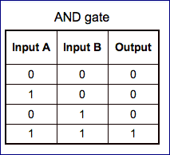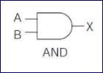

* **OR**: the OR gate produces the inclusive-OR function; that is, the output is 1 if input A or input B or both inputs are 1; otherwise, the output is 0. The algebraic symbol of the OR function is +, similar to arithmetic addition. OR gates may have more than two inputs, and by definition, the output is 1 if any input is 1.

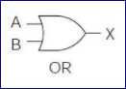 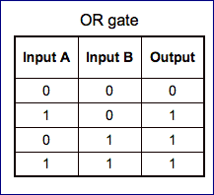

* **Inverter (NOT)**: the inverter circuit inverts the logic sense of a binary signal. It produces the NOT, or complement, function. The algebraic symbol used for the logic complement is either a prime or a bar over the variable symbol.

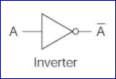 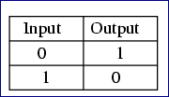

* **NAND**: the NAND function is the complement of the AND function, as indicated by the graphic symbol, which consists of an AND graphic symbol followed by a small circle. The designation NAND is derived from the abbreviation of NOT-AND.

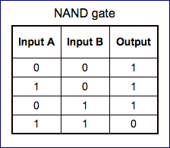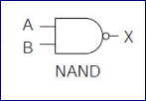

* **NOR**: the NOR gate is the complement of the OR gate and uses an OR graphic symbol followed by a small circle.

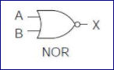 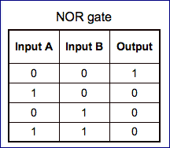

* **Exclusive-OR**: the exclusive-OR gate has a graphic symbol similar to the OR gate except for the additional curved line on the input side. The output of the gate is 1 if any input is 1 but excludes the combination when both inputs are 1. It is similar to an **odd function**; that is, its output is 1 if an odd number of inputs are 1.

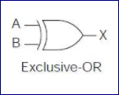 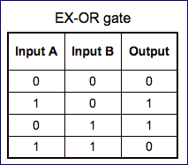

* **Exclusive-NOR**: the exclusive-NOR is the complement of the exclusive-OR, as indicated by the small circle in the graphic symbol. The output of this gate is 1 only if both the inputs are equal to 1 or both inputs are equal to 0.

